A Framework for 21st Century Learning
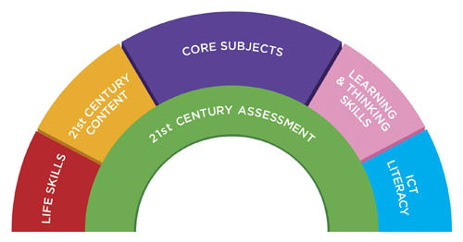
Life Skills | 21st Century Content | Core Subjects | Learning and Thinking Skills | Information and Communication Technology | 21st Century Assessments
- Leadership Initiative  Self-direction  - Ethics  - Accountability  - Adaptability  - Flexibility  - Personal Productivity  - Personal Responsibility  - People Skills  - Social Responsibility | - Global Awareness  - Financial Literacy  - Economic Literacy  - Civic Literacy  - Environmental Literacy  - Business Literacy  - Entrepreneurial Literacy  - Health Awareness  - Wellness Awareness | - English  - Reading/Language Arts  - Mathematics  - Science  - Foreign Languages  - Civics  - Government  - Economics  - Arts  - History  - Geography | - Critical Thinking  - Problem Solving  - Communication skills  - Collaboration  - Information Skills  - Media Literacy Skills  - Contextual Learning Skills  - Creativity and Innovation  Summary: Using problem-solving tools (such as spreadsheets, decision support, and design tools) to manage complexity, solve problems, and think critically, creatively, and systematically. | *Using communication, information processing, and research tools (such as word processing, e-mail, groupware, presentation software, and the Internet) to access, manage, integrate, evaluate, create, and communicate information). These skills include information and media literacy skills. | *Supports a balance of assessments including high-quality standardized testing along with effective classroom formative and summative assessments  *Requires a balance of technology-enhanced, formative and summative assessments that measure student mastery of 21st century skills.

