At Home Comprehension Questions
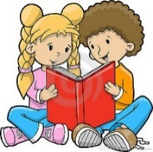
Fiction
*What was the problem in the story and how was it solved? Use parts of the story in your answer.
What made (character do action)? Use parts of the story in your answer.
How did (character) get ___________? Use parts of the story in your answer.
How did (character) find out that (another character) was (action)? Use parts of the story in your answer.
Why do you think (character) cannot _________? Use details from the pictures or from the story in your answer.
Read this from the story. {“Quote from story”} Who says this and why? Use parts of the story in your answer. How does the (character) help ________?
Use parts of the story in your answer. Why did (character do action)? Use details from the pictures or from the story in your answer.
What do you think (character) will do the next time _______________? Use parts of the story in your answer.
Non-Fiction
*In the book I learned ______________. Use parts of the book in your answer.
The book says _________. What might happen if ____________. Use parts of the book in your answer.
Why do you think __________ is important? Use parts of the book in your answer.
Tell how a ___________ and a ___________ are different (or similar). Use parts of the book in your answer.
Describe a _______________. Use parts of the book in your answer.
*Appropriate for lower level texts.

